## Design Outline

### Constants

1. The number of rooms that make the size of the house

Small house = 2

Medium house = 4

Large house = 6

1. Cleaning types:

Light

Complete

1. Cleaning types price list based on the number of houses

Small:

Light = 200

Complete = 250

Medium:

Light = 400

Complete = 450

Large:

Light = 600

Complete = 650

### User input

1. The number of rooms in the customer's house.
2. The type of cleaning they require from the list of; LIGHT or COMPLETE cleaning.

### Program output

1. The cost of cleaning the house.
2. Error message, if the type of cleaning is not in our catalogue.

### 

### Steps on how to achieve this

1. Prompt the user for their input, that is, the number of rooms and the type of cleaning.
2. Validate that the type of cleaning the user has entered is part of the services we offer in our catalogue (LIGHT and COMPLETE)
   1. If it is not in our catalogue, the program outputs an error message telling them we don’t have the service.
3. If it is in our catalogue, we check the number of houses the customer has added, to accurately determine the size of their house.
4. From the size of the house and the type of cleaning, we check out the price list to get the customer's price tag.
5. From the price tag, we compute the total cost of cleaning the house, by multiplying it by the number of rooms in the house.
6. Output the total cost of cleaning the house to the customer.

### Test Cases

| **Test Case** | **Number of Rooms** | **Cost for Light Cleaning** | **Cost for Complete Cleaning** |  |
| --- | --- | --- | --- | --- |
| Test case 1 | No. of rooms = 2 | $400 | $500 |  |
| Test Case 2 | No. of rooms = 3 | $1200 | $1350 |  |
| Test case 3 | No. of rooms = 10 | $6000 | $6500 |  |

### 

### Screenshots

#### Test Case 1

#### 

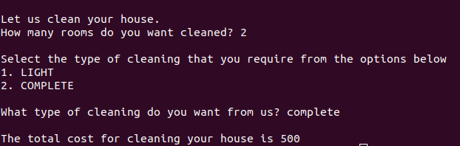

#### Test Case 2

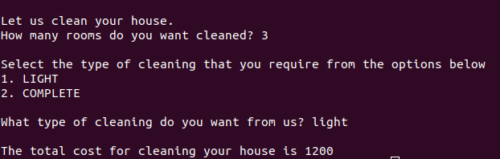

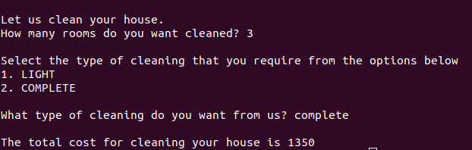

#### Test Case 3

